Results of the second HotSW IDE Panel Survey

Background
The IDE Panel is a volunteer group of entrepreneurs and leaders in innovation driven enterprises (IDEs). The IDE Panel was established as a recommendation of the MIT-REAP exercise in which the HotSW LEP took part alongside other member s of the regional innovation ecosystem. The make-up of the IDEs is provided in the Annex.
The second survey, discussed in greater detail below, covers:
- Gathering experiences of applying (or not) for Innovation Grants
- Understanding the kind of Tech that IDEs would love us to have available in the region (probably via FE, HE or Innovation Centres/Science Parks)
- Understanding some of the current barriers to innovating around manufacturing
- University of Exeter’s Business School offer to SMEsx
Just below half of the IDE Panel members responded (18 of 41) which gives us some useful qualitative intelligence.

Experiences of Applying for Innovation Grants
When asked if they had ever applied for an Innovation Grant, 61% of respondents (Figure 1.)
Figure 1. Applications for Innovation Grants
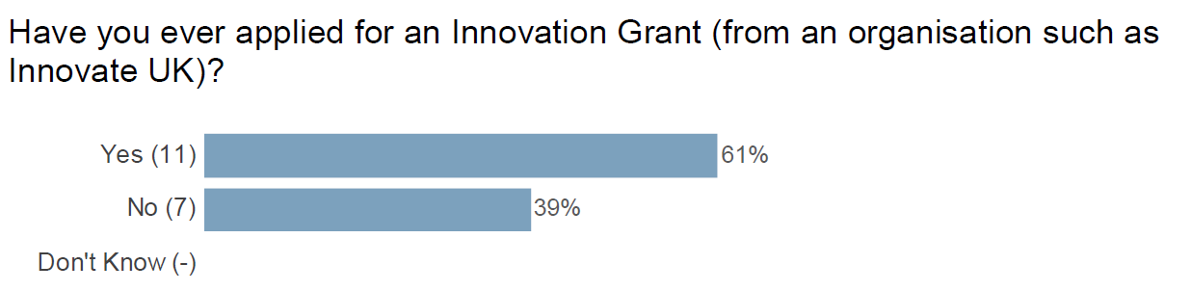
Of those responding ‘Yes’, over 80% were successful in their application. For those who responded no, reasons included the following

Not suitable to their needs
- This was rarely elaborated on beyond not needing the grant.

Awareness of grants
- One respondent stated that they did not know that these grants existed.
- In another case, the respondent reported lacking the experience and resources to know about the grants and whether Innovation grants would suit them.
- There were also reports of clarity problems with the grant requirements.
- A respondent reported being unsure as to why they hadn’t applied before, as they had applied for similar support from US funds in the past.

Eligibility issues
- One respondent had issues with the required life length of the business and was intimidated by the complexity of maintaining the other requirements.
There was also scope for respondents to provide their thoughts about the process, including whether they worked with other enterprises and where they would have appreciated further assistance:
- There were further mentions of the process seeming intimidating, including mention of the support company Grantify and concerns that the process is both daunting for first time applicants and difficult to justify the time and expense for SMEs.
- Other sources of support mentioned include Innovate UK and Business West, as well as peers in enterprise.
- A respondent expressed concern that the additional, unfunded, administrative work required took away a notable amount of the impact of the support: this is similar to another respondent expressing that the upfront bid process was something of an overhead.
- One respondent would prefer an option to have a 1 to 1 interview rather than having to rely on pitches.

Summary
40% of respondents had not applied for grants. However - the clear majority of those who had, had been successful. The general impression of applying for grants, was that it was challenging, especially for first time applicants and SMEs.

General Business Practices
The survey asked IDEs about their general business practices. This includes planning ahead around innovation as well as accounting for sustainability needs and automation options. It also looks at whether IDEs are engaging with ISO14001 certification, and if not, whether they need help to do so.

Innovation and Improvement and Sustainability Plans
Of the 18 respondents, 14 respondents had an innovation plan projecting into the next 3-5 years.
Figure 2. Innovation/improvement plans
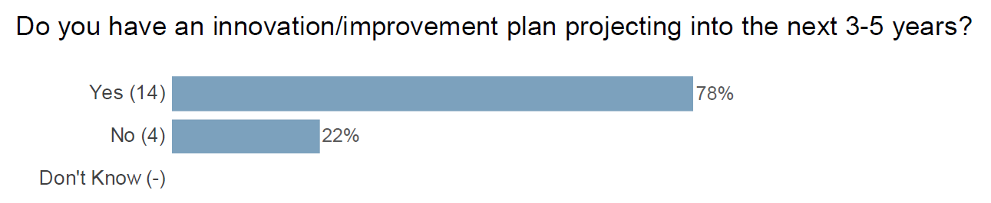
The respondents were asked to elaborate in the case that they did have an innovation plan in place. The first of these was a query as to whether they felt their organisation had the skills internally to deliver the planned projects, with 57% of respondents confirming that they did. This section also asked whether respondents with innovation/improvement plans intended to use automation of physical tasks as part of the plan. The gap here was wider, with 69% of respondents saying yes.
This section also discussed whether respondents were looking to automate other routine tasks such as administration and data capture. While 83% of respondents confirmed that they were, only 50% believed that they had the appropriate skills internally to achieve this.
Respondents were also asked if they have a Sustainability Plan (Figure3). The majority did have a plan of this kind.
Figure 3. Sustainability plans
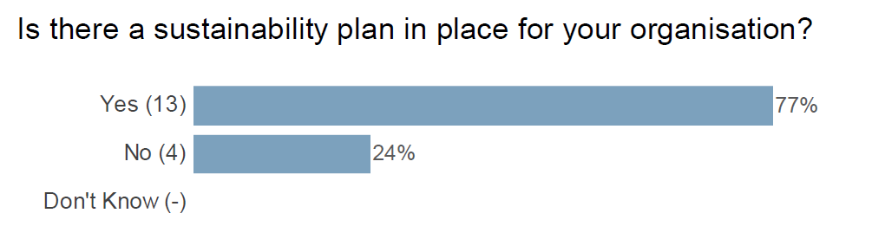
We also asked about ISO4001 certification (Figure 4). This links into the sustainability question mentioned above. 61% of respondents did not have ISO4001 certification, with one respondent unsure. 73% of respondents that said thought that the Heart of the South West LEP should be doing more to help local enterprises manage their environmental impact.
Figure 4. ISO4001
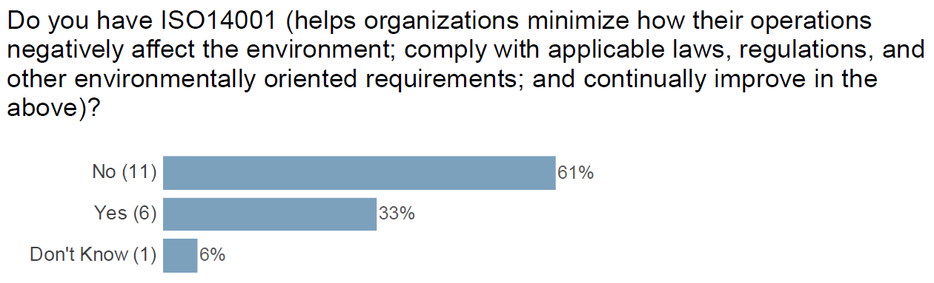

Summary
The IDEs largely had short term plans in place for innovation and improvement, as well as sustainability plans. While a majority thought they had the skills required to implement these plans, this was only a little over half. More respondents intended to use automation as part of their plan implementation, than not. Over half of respondents lacked ISO4001 certification. 73% believed that the LEP should be doing more to support local enterprises with managing their local environmental impact.

Technical needs
A key part of understanding the innovation landscape is understanding the challenges and opportunities posed by technological development. While IDEs are, by definition, innovation driven, not all such enterprises have access to the technology that would best help them to succeed, as shown in Figure 5 below.
Figure 5. Technology needs
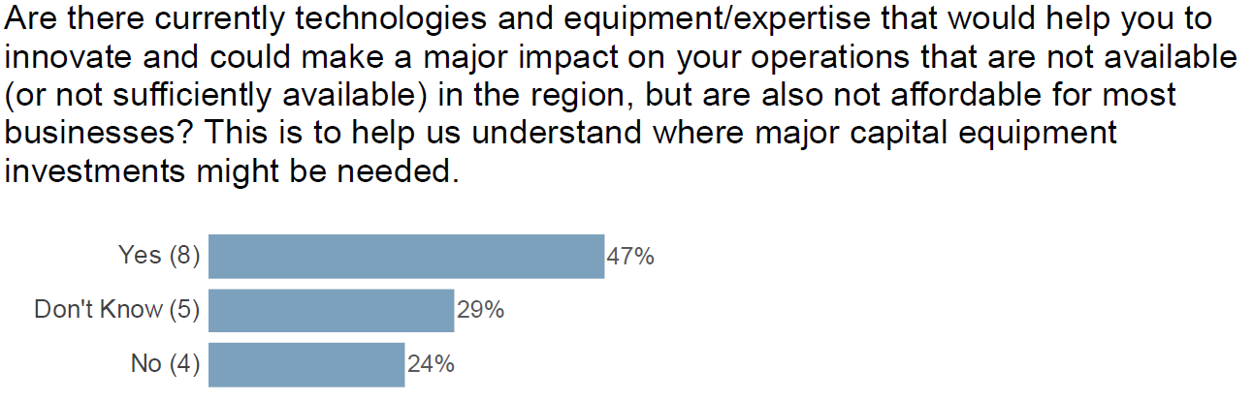

This question is not as simple as the three-option answer might suggest: to expand on this, the survey included an option to elaborate where the answer was yes. Suggestions for required technology for innovation included:
- Blockchain development and in particular secure contract development is not well catered for in my area.
- Prototyping and small batch production and design are areas that we need assistance with. Having those technologies and expertise in-house would save us a huge amount of time in bringing products to market. Our experience of outsourcing has been OK in terms of expertise and quality but huge delays are in the time it took to progress. Science Park. University, etc are OK if easier to access and park.
- Manufacturing and textile expertise in general. We simply do not have enough textile technicians to progress as rapidly as we would like with our development projects. We do not have the experts in automation and robotics that we require to maintain and increase our productivity.
- Manufacturing assembly equipment such as die bonders, wire bonders and State of the Art Test equipment are all prohibitively expensive to small businesses who are unable to access funding.
- Mid-tech space; light engineering, office use and meeting space
- Data / AI expertise for digital platform build incorporating data insight on 'joining' and ongoing use of platform (covering business support, innovation, funding and talent needs), ongoing engagement profiling of tech company needs / pain points etc
- We want to be net zero but are struggling to find an industrial/workshop space that is carbon neutral/negative and affordable and accessible. As a growing business, rental terms of 3 years are not flexible enough for our changing needs. We're on the Science Park but it doesn't provide the 'dirty' workshop or storage space that we need. We want to encourage carbon neutral travel/delivery/collection options, but the charging infrastructure is not in place yet for us to push this down our supply chain. Our innovations are all around sustainability and resource use, so it feels like there is a fundamental gap there at the moment. More EV, carbon neutral, flexible space around this EZ area would be amazing. Another aspect of technical need in innovation is the ongoing digitalisation trend.

Digitalisation
When asked about the need to digitise existing processes to remain competitive (Figure 6), while a simple majority said yes, over half of respondents said no or that they didn’t know when discussing whether they need to digitise existing processes to stay competitive. The majority was larger when discussing whether processes could be consolidated (Figure 7).
Figure 6. Digitalisation
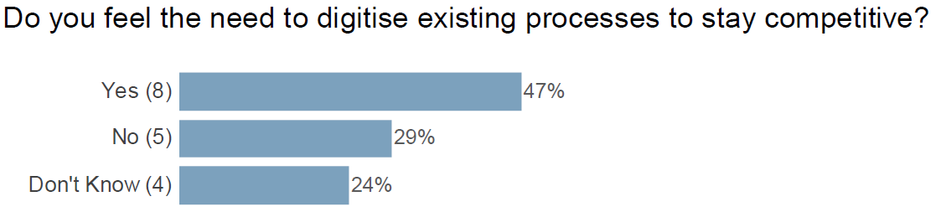
Figure 7. New technology
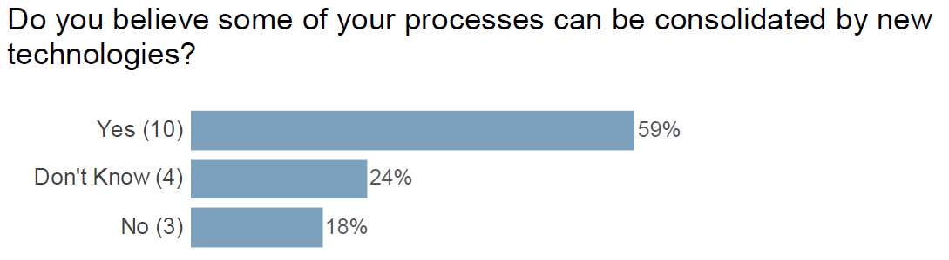
Both of these questions included options to elaborate for respondents that said yes. For digitising processes, respondents replied with changes they needed to make including the following:
- We are working with NFT'S and therefore the whole coding process is part of our project but also developing of the platform
- Design and prototyping as well as testing
- We plan to install robotic mould machining in our foundry
- We are already well up to speed from a business and conventional design perspective. Additional aspirations mainly associated with virtual environments for simulation, testing, refinement, training and opp control.
- Xero and Salesforce are to be procured
- Back end to support the team - so probably more around managing our work / and then starting to draw in external data sources in time.
- Operating in a digital environment means that tech skills are needed but computers have the ability to operate more efficiently, faster, and cheaper than people even with tech skills.
Meanwhile, the question about consolidating processes using new technologies asked which processes the IDEs were looking to consolidate. These included
- Support Helpdesk services and customer CRM
- Secure contracts offer a good space to consolidate
- Some process steps could be eliminated with new technologies.
- Reducing moulding from 3 parts to two parts through different design and moulding technique.
- Design, test, validate, iterate, demo, train and user planning.
- Sales and accountancy
- Not clear yet - we need to do this work over the next 12-18 months. Could be using pre-existing tools -
- client management, content management, social media tracking and analysis.
- Instead of offering a manual adjustment to customers on an individual basis we will be looking to
- develop programs to automate the shapes and sizes of our templates and the features contained within our design plans.
- the creation of a DAO and the development of smart contracts
Looking to the future, IDEs need to be able to securely plan, and as such the survey asked about risk as a barrier to innovation, including whether IDEs would be interested in access to an environment with new technologies.

De-Risking the Business Case
We asked whether access to an environment with new technology would help with making safe assessments and de-risking the business case (Figure 8). There was a very strong positive response for this.
Figure 8. De-risking business cases
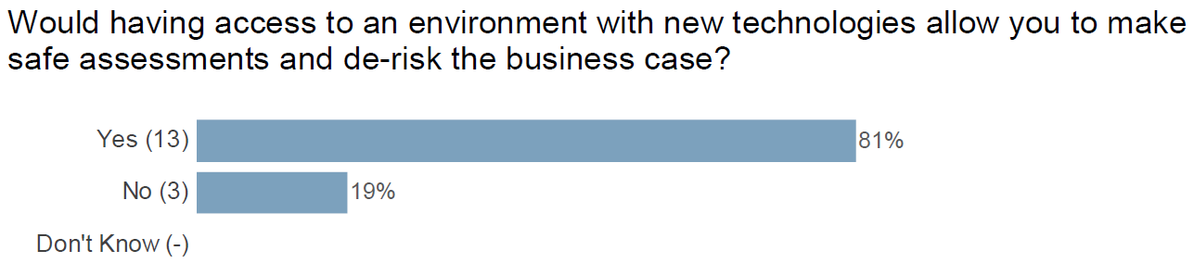
Due to the varied needs of different enterprises, respondents were encouraged to elaborate on this answer. Responses included:
- We constantly look to test and build new High Performance Computing systems. Access to new hardware would allow us to get new products to market quickly while reducing the risk.
- We are not in the manufacturing space. We are in the Big Data / AI / Analytics space
- Collaboration areas (hot desks) would give us a larger pool of talent to pick from
- Always better to evaluate new technologies and processes in a safe, non sales environment
- It would be good to be able to see what technologies are on offer to automate production and test options.
- We provide packaging services to emerging technologies and therefore need access to the newest technologies.
- Potentially so, though access to associated expertise likely to be more valuable than hardware/software alone.
- Evaluation of products has been straight forward without access to such an environment
- Having a business idea that is wholly dependent upon tech, yet not having a tech background, let alone tech expertise, it would be helpful in my case to know of and/or have access to a tech ‘hub’ whereby indeterminate and inadequately expressed technological needs might be analysed, understood and perhaps referred to sources of relevant expertise. A general filter or signposting system to match tech need (expressed in a basic, non tech manner) with people who or businesses that can satisfy that need, no matter what the level of complexity.
- The main reason for employment is networking and marketing so having an environment where this can be done plus being able to then utilize the new connections made immediately would cut down time significantly.
- We are developing hardware and would prefer to small batch manufacture but haven't explored the options yet.
As mentioned above, some respondents showed interest in opportunities to share expertise and otherwise network.

Summary
Only half of our IDEs were positive that they had access to the kinds of technology that would best help them to succeed. The areas cited where technology would help were largely areas where other IDEs are already providing potential solutions that could benefit them.
Over half of respondents said ‘no’ or that they ‘didn’t know’ about the need to digitise existing processes to remain competitive. There was a very strong positive response for greater access to an environment with new technology that would help with making safe assessments and de-risking the IDE’s business case.

Understanding some of the current barriers to innovating around manufacturing
We asked a number of questions targeting the manufacturing sector. The first of these related to access to expertise before adopting new technologies. This generated a lot of negative and ‘don’t know’ responses (Figure 9).
Figure 9. Unbiased knowledge on new manufacturing tech
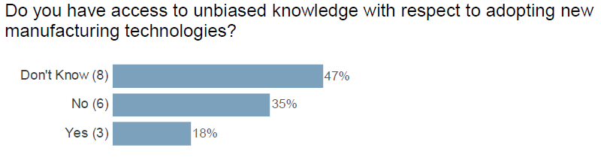
For those who responded yes, the sources of advice given were Innovate UK Edge and SWMAS, as well as a team of experts built up by the specific enterprise. Meanwhile, two of those who responded no stated that they did not need this knowledge. The remaining no responses included the following when asked what they needed:
- New manufacturing technologies are usually presented to us by companies with products to sell. This means that we could be missing better technologies just because the salespeople with the best technology are not finding us.
- Given the specialised nature of our products I suspect we need expertise and experience that does not currently exist. However in general 'generic' advice that does not include clear pointers to possible solutions (including contacts) is less helpful.
- Discuss and collaborate with established specialists
- Working on a start-up can be a very isolating experience, especially if you’ve moved outside of your sector or field of experience. Even knowing where to go to ask for the first level of support can be a problem. This leads to paralysis and doubt rather than development and progress.
In terms of the current state of the innovation environment, the survey asked respondents as to whether their products and innovation were constrained by currently available technologies (figure 10). The same number of respondents said, ‘Don’t Know’ as ‘No’, with less than 30% stating that they were constrained by current technology.
Figure 10. Unbiased knowledge on new manufacturing tech
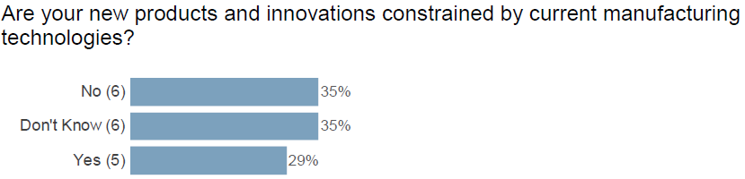
As with some of the previous questions, this is a question with a variety of reasonings behind it and was matched with an option for further elaboration. Three respondents clarified that manufacturing technology was not relevant to their enterprise.
Manufacturing Limitations
- We are at the leading edge of integration of Solar / Battery technology. The SWAP impact of the current technology is a limiting factor in future development
- In order to compete globally from a relatively high wage and energy cost country with high
environmental protection costs we need cutting edge manufacturing technologies to reduce labour costs, energy consumption and water consumption etc. We also need to be able to maximise manufacturing output in the smallest possible space.
- We provide packaging services to emerging technologies and therefore need to stretch current technological limitations.
Currently Stable, Unsure or Separate Challenge
- The tech is in place
- I am sure improvements can be made if we had better knowledge of what is out there now and into the future
- Our products are designed to avoid reliance on complex manufacturing technologies, partly reflecting the above, but also to minimise reliance on technologies, materials etc that may constrain development of the business.
- There is no real limit to the tech it's simply a financial issue of affordability.
- Not sure about economics of 3D printing vs mass production but would prefer local and small as it allows us to adapt the hardware during this early stage of development.
The final questions in this section concerned the efficiency of the manufacturing process: the first concerned whether the IDEs feel that their manufacturing process is lean enough. There was a simple majority in favour of No, followed by answers of Don’t Know.
Figure 11. Lean manufacturing
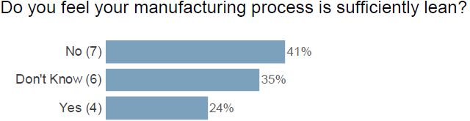
The other question on manufacturing efficiency concerned the ability to resolve existing problems: troubleshooting exists as a different set of issues to the processes used generally (Figure 12).
Figure 12. Root causing manufacturing problems
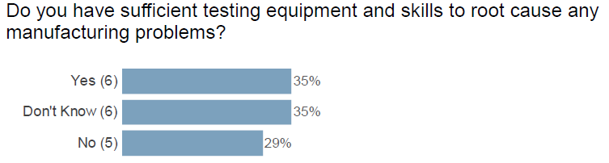

Summary
Less than a third of respondents believed that they were constrained by current manufacturing technologies, but under a third believed that their manufacturing processes were lean enough. A simple majority of the respondents were unsure if they had unbiased information on new technologies, followed by those who said no. There were split responses on whether IDEs had sufficient testing equipment and skills to root cause problems.

University of Exeter's Business School offer to SMEs
One of the major institutions for the development of innovation projects in the Heart of the South West LEP area is the University of Exeter. The University of Exeter offers a variety of forms of business support: however, this does not necessarily mean that local IDEs are aware of these possibilities.
A grid-based question in this section asked if respondents were aware of particular support options: in order of level of awareness, they were aware that entrepreneurs could:
- Attend an event, conference or workshop? – 65% said yes
- Recruit students and alumni? – 61% said yes
- Complete a development course or programme? – 47% said yes
- Join the business Incubator or Accelerator programmes? – 41% said yes
- Take part in research? – 39% said yes
- Commission a research or consultancy project? – 39% said yes
- Apply for research funding? – 35% said yes
Respondents were also asked to rank these options by how much they were interested in them (Figure 13), as well as a final question on whether there was anything else that the business school could offer that would be of interest to them. In response to the latter, our IDEs were most interested in applying for research funding and recruiting students and alumni. Only one respondent chose development courses or programmes.
Figure 13. Unbiased knowledge on new manufacturing tech
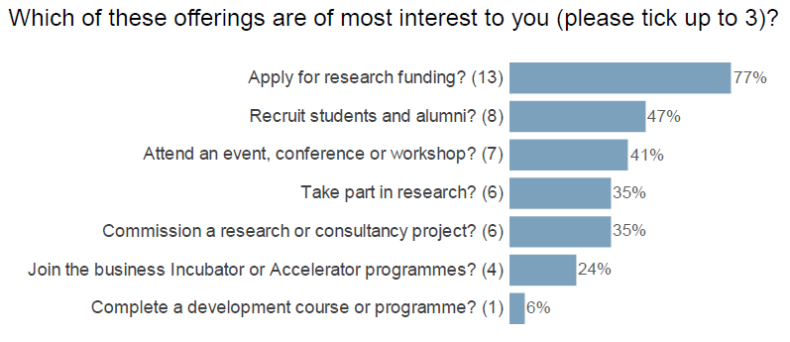

Summary
The awareness rates for University of Exeter Business School reports were somewhat mixed: the largest percentage was awareness of attending conferences, events, or workshops at 65%, with applying for research funding the lowest at 35%. Interestingly this was the highest voted option when respondents were asked which offers they would be most interested in.

ISO4001 is an international standard for designing and implementing an environmental management system (EMS), a system comprised of the policies and processes that affect how a company engages with its environment.

